**Response for Assignment 13**

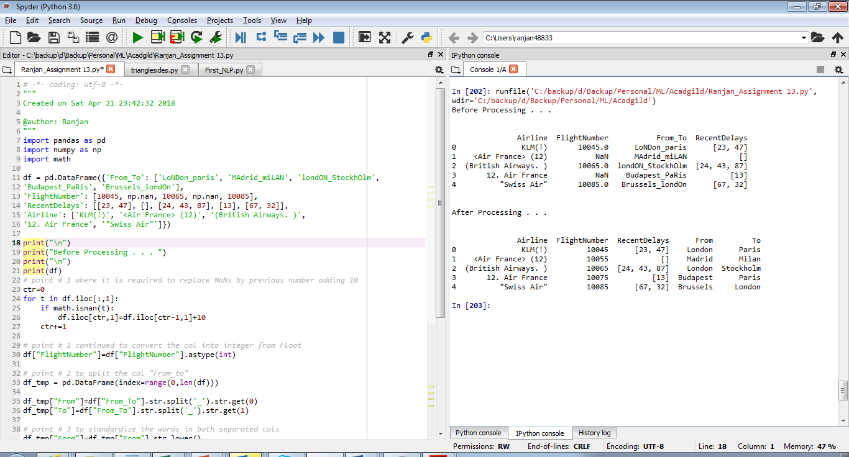

**Below is the source code**

"""

Created on Sat Apr 21 23:42:32 2018

@author: Ranjan

"""

import pandas as pd

import numpy as np

import math

df = pd.DataFrame({'From_To': ['LoNDon_paris', 'MAdrid_miLAN', 'londON_StockhOlm',

'Budapest_PaRis', 'Brussels_londOn'],

'FlightNumber': [10045, np.nan, 10065, np.nan, 10085],

'RecentDelays': [[23, 47], [], [24, 43, 87], [13], [67, 32]],

'Airline': ['KLM(!)', '<Air France> (12)', '(British Airways. )',

'12. Air France', '"Swiss Air"']})

print("\n")

print("Before Processing . . . ")

print("\n")

print(df)

# point # 1 where it is required to replace NaNs by previous number adding 10

ctr=0

for t in df.iloc[:,1]:

if math.isnan(t):

df.iloc[ctr,1]=df.iloc[ctr-1,1]+10

ctr+=1

# point # 1 continued to convert the col into integer from Float

df["FlightNumber"]=df["FlightNumber"].astype(int)

# point # 2 to split the col "From_to"

df_tmp = pd.DataFrame(index=range(0,len(df)))

df_tmp["From"]=df["From_To"].str.split('_').str.get(0)

df_tmp["To"]=df["From_To"].str.split('_').str.get(1)

# point # 3 to standardize the words in both separated cols

df_tmp["From"]=df_tmp["From"].str.lower()

df_tmp["From"]=df_tmp["From"].str.capitalize()

df_tmp["To"]=df_tmp["To"].str.lower()

df_tmp["To"]=df_tmp["To"].str.capitalize()

# point # 4 to delete the "From_To" col and attach the temporary DataFrame

df=pd.concat([df,df_tmp],axis=1)

df=df.drop("From_To",1)

print("\n")

print("After Processing . . . ")

print("\n")

print(df)

# point # 5 has not been done